Cocaine Anonymous
World Service Archive Committee

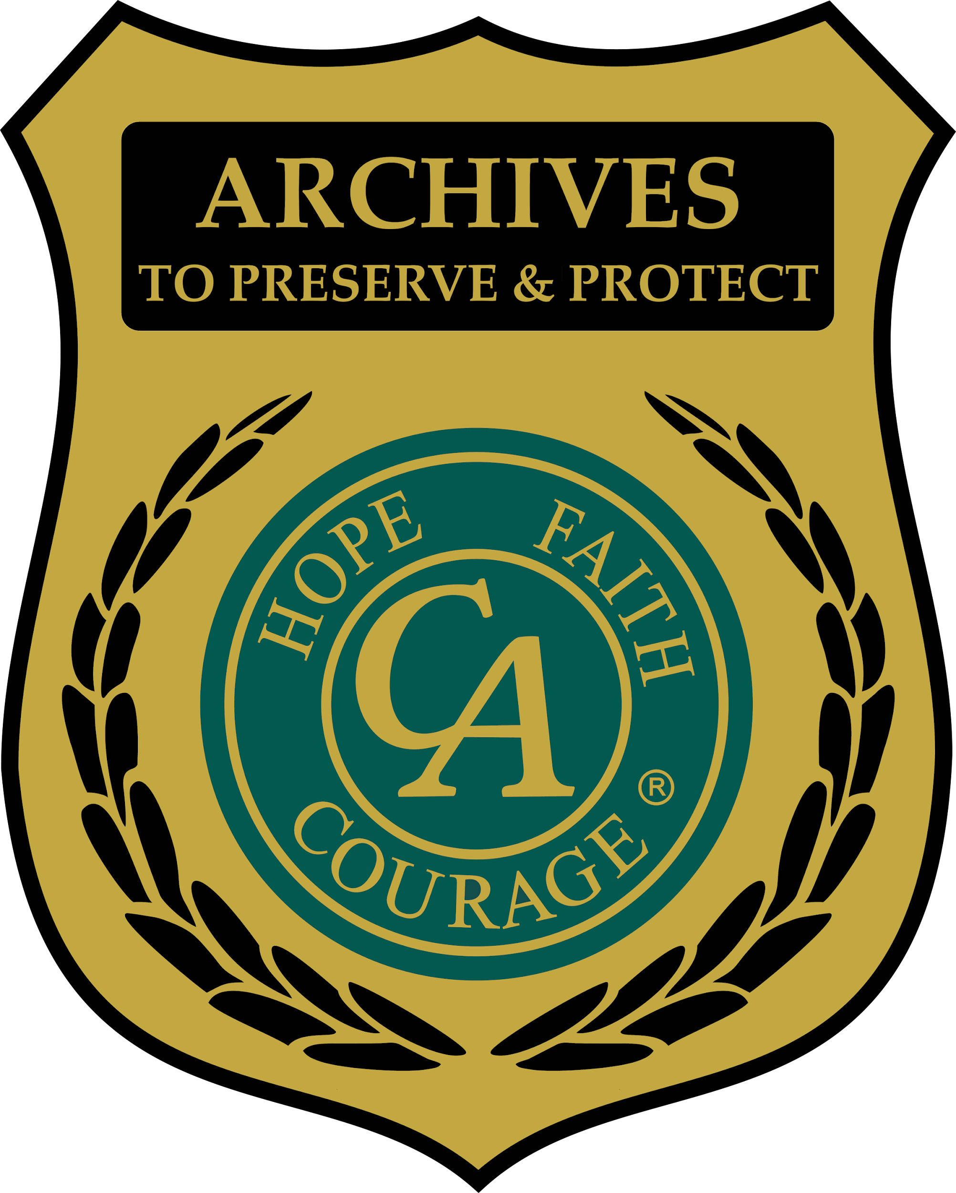

"Protecting C.A.'s Future By Preserving C.A.'s Legacy"

https://ca.org/service/world-service-conference/archives/

“Pass-It-On”
Archiving Guidelines and Procedures

TABLE OF CONTENTS

Introduction - page 3
CAWS Archive Committee Structure - page 4
Committee Roles, Duties and Responsibilities - page 5
Procedures & Practices - - page 10
Organizing the Archive - page 14
Cataloging the Archive - page 16
Archive Displays for C.A. Events - page 16
Creating a Digital Archive - page 17
Creating an Audio Archive - page 25
Appendix I: Sample of an Audio Release Form - page 29
Appendix II: Deed of C.A. Gift Form - page 30
Appendix III: Example of a Box Inventory Record - page 31
Appendix IV: Example of a Blank Box Inventory Record - page 32

INTRODUCTION

The purpose of the Cocaine Anonymous World Services (CAWS) Archive Committee is to document the work of Cocaine Anonymous, make the history of the organization accessible to C.A. members and to provide a context for understanding C.A.'s progression, principles and traditions. Thus, the CAWS Archive Committee collects, preserves, catalogs and curates the CAWS Archive, which holds valuable documentation about C.A. actions and accomplishments that are intrinsic to our collective memory. These records establish and maintain our identity as a Cocaine Anonymous members and tell us stories to help us to understand of our fellowship, both locally and globally—focusing our C.A. identity and facilitating C.A. Unity.

ABOUT THE CAWS ARCHIVE COMMITTEE

Tradition Nine: C.A., as such, ought never be organized; but we may create service boards or committees directly responsible to those they serve.

An Archive Committee ought to be comprised of positions elected by the Archive Committee:

- ARCHIVE CHAIR
- VICE-CHAIR
- SECRETARY
- CO-SECRETARY
- OUTREACH SUB-COMMITTEE CHAIR
- CONVENTION LIAISON
- ARCHIVISTS & CURATORS
- COMMITTEE MEMBERS

THE ROLE OF THE ARCHIVE COMMITTEE

Concept Ten: Every service responsibility should be matched by an equal service authority — the scope of such authority to be always well defined whether by tradition, by resolution, by specific job description or by appropriate charters and bylaws.

The Archive Committee ought to maintain responsibility and authority, as suggested in Concept Ten, for the uses of the archives, as well as all other matters of policy through its collective group conscience, including: establishing policies, budgets, and procedures—exercising its group conscience in regard to matters of general policy. In all of its actions, the CAWS Archives Committee needs to be mindful of and guided by C.A.'s primary purpose, “to carry the C.A. message to the addict who still suffers.”

- To Liaise with the fellowship
- Establish working relationships with Area Archive Chairs and Archivists
- To make the Archive Accessible to the fellowship
- Rotating Positions
- Be an Elder States-person

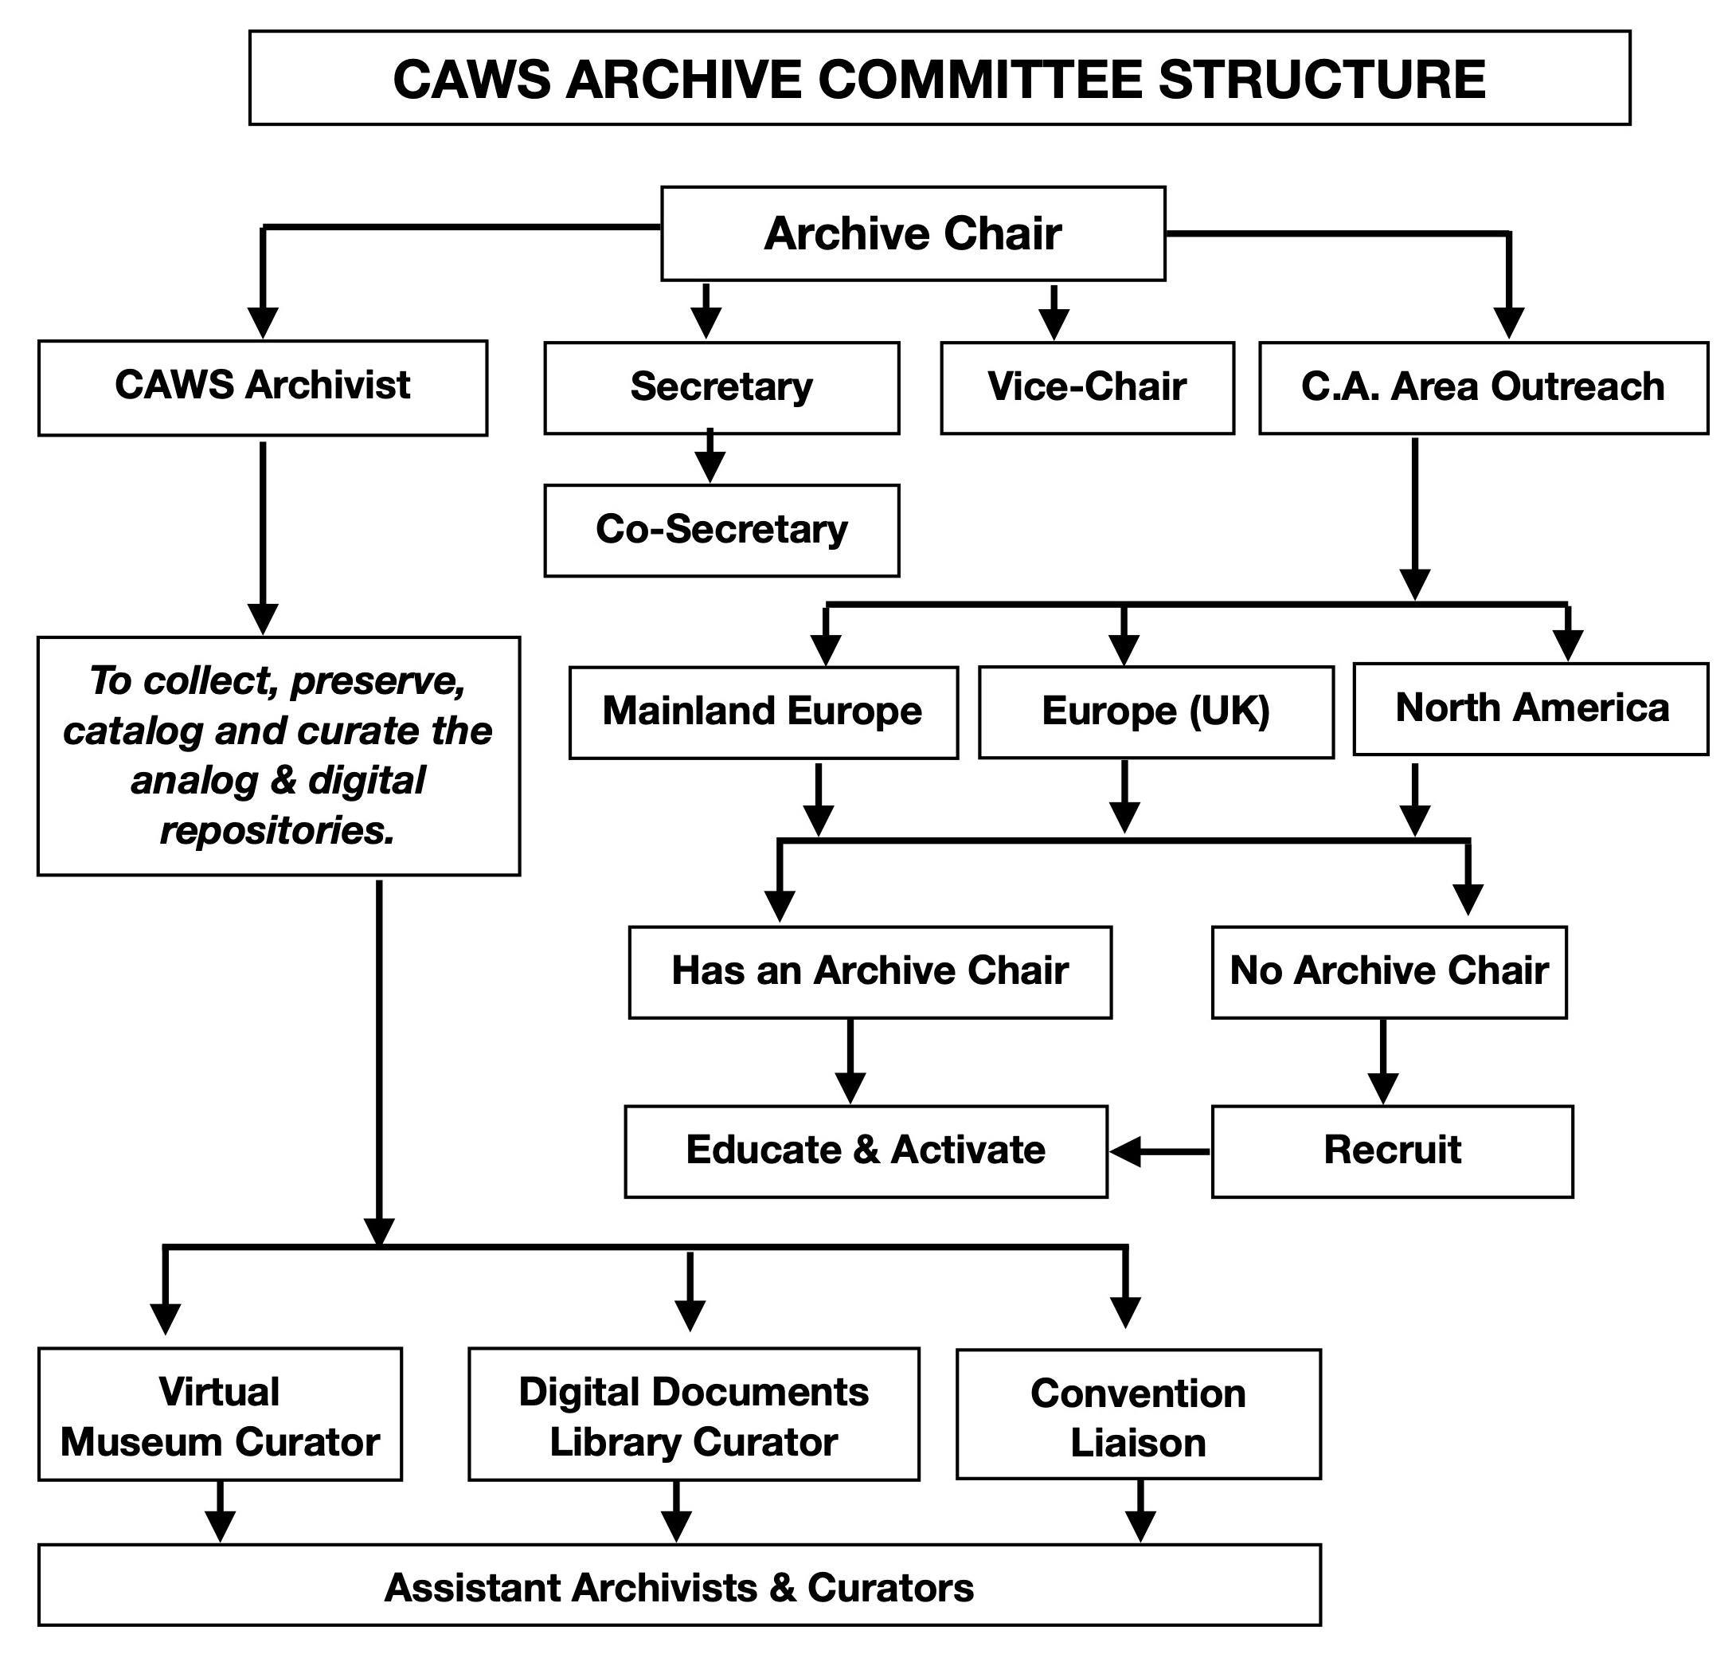
CHAIRPERSON - 2 Year Term

Prerequisite: A minimum of two (2) years continuous sobriety. A minimum 1 year previous experience on the Conference floor and a minimum of 1 year experience as a member of the CAWS Archive Committee.

Recommended Experience: A C.A. member and elder states-person who is familiar with The Twelve Steps, Twelve Traditions and Twelve Concepts of Cocaine Anonymous and has proven organizational skills, proficient interpersonal skills, and a working knowledge of computers—ideally both personal and server-side skills are an asset. The Chairperson candidate ought have a strong working knowledge of the policy, procedures and Guidelines of the Archive Committee.

Responsibilities:

- Non-voting member of the Archive Committee.
- Schedule and Attend Archive Committee Meetings.
- Attend the World Service Conference.
- Upholds The 12 Traditions And 12 Concepts.
- Provides general guidance and oversight of all committee activities, including, collecting, preserving, cataloging and curating archive materials.
- Act as a parliamentarian during Committee business.
- Act as the liaison between the Archive Committee and WSOB on matters of budgets, repository needs, access to the World Service office equipment i.e. scanner, printer, etc.

—————————————————-

Vice Chairperson – 2 Year Term

Prerequisite: A minimum of two (2) years continuous sobriety. A minimum 1 year previous experience on the Conference floor and a minimum of 1 year experience as a member of the CAWS Archive Committee.

Recommended Experience: A C.A. member and elder states-person who is familiar with The Twelve Steps, Twelve Traditions and Twelve Concepts of Cocaine Anonymous and has proven organizational skills, proficient interpersonal skills, and a working knowledge of computers—ideally both personal and server-side skills are an asset. The Vice-Chairperson candidate ought have a good working knowledge of the policy, procedures and Guidelines of the Archive Committee and has the ability to lead the Committee in the absence of the Chair.

Responsibilities:

- Voting member of the Archive Committee.
- Attend Archive Committee Meetings.
- Attend the World Service Conference.
- Upholds The 12 Traditions And 12 Concepts.
- Learn the duties and responsibilities of the Chairperson.
- Assume all responsibilities in the event the Chairperson is unavailable or unable to attend the Conference.
Secretary - 2 Year Term

Prerequisite: A minimum of two (2) years continuous sobriety.

Recommended Experience: A C.A. Member and elder states-person who is familiar with The Twelve Steps, Twelve Traditions and Twelve Concepts of Cocaine Anonymous and has good organizational skills, as well as excellent communication and interpersonal skills. Computer skills are an asset, especially keyboarding. The Secretary candidate ought to have a working knowledge of the policy, procedures and Guidelines of the Archive Committee.

Responsibilities:

- Voting Member of the Archive Committee.
- Attend Archive Committee Meetings.
- Attend the World Service Conference.
- Upholds The 12 Traditions And 12 Concepts.
- Keep accurate notes and record the minutes of the Archive Committee meetings.
- Participate in the archival process by assisting in collecting, preserving and cataloging items for the Archive.
- Keep copies of the minutes in electronic formats, i.e. docx and pdf.
- Record committee conference calls, backed by email for all committee meetings.
- Assist the Chair in preparing Conference Reports

—————————————————-

Co-Secretary - 1 Year Term

Prerequisite: A minimum of two (2) years continuous sobriety.

Recommended Experience: A C.A. Member and elder states-person who is familiar with The Twelve Steps, Twelve Traditions and Twelve Concepts of Cocaine Anonymous and has good organizational skills, as well as excellent communication and interpersonal skills. Computer skills are an asset, especially keyboarding. The Secretary candidate ought to have a working knowledge of the policy, procedures and Guidelines of the Archive Committee.

Responsibilities:

  - Learn duties and responsibilities of the Secretary position.
  - Assist Secretary when needed.

—————————————————-

Outreach Chair – 1 Year Term

Prerequisite: A minimum of two (2) years continuous sobriety.

Recommended Experience: A C.A. Member who is familiar with The Twelve Steps, Twelve Traditions and Twelve Concepts of Cocaine Anonymous and has good organizational skills, as well as excellent communication and interpersonal skills. Computer skills are an asset. The Outreach Chair ought to have a working knowledge of the policy, procedures and Guidelines of the Archive Committee.

Responsibilities:

- Voting Member of the Archive Committee.
- Attend Archive Committee Meetings.
- Upholds The 12 Traditions And 12 Concepts.
- Contact Area Chairs and Area Delegates and assist to recruit an Area Archive Chair where none exists.
- Submit detailed WRITTEN reports on calls and outcomes on monthly basis.

—————————————————-

CAWS Convention Archive Liaison position - 1 Year Term

Prerequisite: A minimum of two (2) years continuous sobriety.

Recommended Experience: A C.A. Member and elder states-person who is familiar with The Twelve Steps, Twelve Traditions and Twelve Concepts of Cocaine Anonymous and has good organizational skills, as well as excellent communication and interpersonal skills. Basic computer skills are an asset. Have a working knowledge of the policy, procedures and Guidelines of the Archive Committee.

A. Contact the upcoming CAWS Convention Steering Committee.
B. Collect CAWS Convention artifacts for the archive repository, including:
  - Convention program
  - Ephemera (coins, pens, buttons, tickets, patches, fridge magnets, key-tags, etc.),
  - Textiles (i.e. t-shirt, hoodie, hats, etc., if resources permit)
  - Convention Steering Committee Minutes (digital documents)
  - Hi-resolution digital artwork (i.e. logo, etc.)
  - Digital recording of Convention speakers and workshops.
C. Responsible to create a budget of monies needed to acquire these artifacts which will be paid for out of the CAWS Archive yearly budget.
D. Responsible to compile (4) Flip Books with 80 inserts of various early CA fliers, ephemera, posters, etc., for the upcoming World Convention. (Note: flip books are compiled every year by Archives and presented to the Host Area’s Archive Committee as a gift from the World Archive Committee).
—————————————————-

CAWS ARCHIVIST (Analog & Digital) - Indefinite Term

Tradition Eight: Cocaine Anonymous should remain forever nonprofessional, but our service centres may employ special workers.

From shared experience we know that it takes a considerable amount of time to become familiar with a collection of historical information. Thus, “in the spirit of rotation — the more responsible the assignment the longer the term of service must be if we are to have effectiveness. Bill Wilson writes that for a trustee to be of any use whatever they must serve four years.” (CA NewsGram, Third Quarter 2003, Vol. 19 No. 3. Concept Eleven—Best possible ‘members’) Therefore, it is recommended that the archivist NOT rotate frequently. (A.A. Archives Workbook, 2001)

Prerequisite: A minimum of two (2) years continuous sobriety. It is suggested that the Analog Archivist be a C.A. member who is in close proximity to the analog repository, whereas the Digital Archivist can work virtually with digital repository and can reside anywhere.

Recommended Experience: A C.A. Member and elder states-person who is familiar with The Twelve Steps, Twelve Traditions and Twelve Concepts of Cocaine Anonymous and has good organizational skills, as well as excellent communication and interpersonal skills. Should have strong computer skills, both personal and server-side, as well as experience with office equipment—scanners, photocopiers, Optical Character recognition software (OCR). The Archivist ought have a strong working knowledge of the policy, procedures and Guidelines of the Archive Committee. Archiving knowledge and practice is an asset.

Responsibilities:

- Voting Member of the Archive Committee.
- Attend Archive Committee Meetings.
- Upholds The 12 Traditions And 12 Concepts.
- SERVE as the focal person for the collection/repository.
- Responsible for collecting, preserving, cataloging and curating the CAWS archives.
- Liaises with the Archive Chair and Committee members.
- Acts as the guardian of the analog & digital repositories and is responsible for their protection, security, and maintenance.
- Subject to a performance review and re-ratification every 2 years by the Archive Committee.
—————————————————-

VIRTUAL MUSEUM CURATOR (Digital) - Indefinite Term

Prerequisite: A minimum of two (2) years continuous sobriety.

Recommended Experience: A C.A. Member and elder states-person who is familiar with The Twelve Steps, Twelve Traditions and Twelve Concepts of Cocaine Anonymous and has good organizational skills, as well as excellent communication and interpersonal skills. Ought to have strong computer skills, including keyboarding, Wordpress, Graphic Arts, Word, Excel, and PPT. Experience with office equipment such as, scanners, photocopiers and optical character recognition (OCR) software is an asset. Curators ought to have a working knowledge of the policy, procedures and Guidelines of the Archive Committee. Archiving knowledge and practice is an asset.

Responsibilities:

- Voting Member of the Archive Committee.
- Attend Archive Committee Meetings.
- Upholds The 12 Traditions And 12 Concepts.
- ASSIST the CAWS ARCHIVIST in maintaining, updating and protecting the C.A. Virtual Museum (https://museum.ca.org).
- Subject to a performance review and ratification every 2 years by the Archive Committee.
—————————————————-

CAWS DOCUMENTS LIBRARY CURATOR (Digital) - Indefinite Term

Prerequisite: A minimum of two (2) years continuous sobriety.

Recommended Experience: A C.A. Member and elder states-person who is familiar with The Twelve Steps, Twelve Traditions and Twelve Concepts of Cocaine Anonymous and has good organizational skills, as well as excellent communication and interpersonal skills. Ought to have strong computer skills, including keyboarding, Wordpress, Graphic Arts, Word, Excel, and PPT. Experience with office equipment such as, scanners, photocopiers and optical character recognition (OCR) software is an asset. Curators ought to have a working knowledge of the policy, procedures and Guidelines of the Archive Committee. Archiving knowledge and practice is an asset.

Responsibilities:

- Voting Member of the Archive Committee.
- Attend Archive Committee Meetings.
- Upholds The 12 Traditions And 12 Concepts.
- ASSIST the CAWS ARCHIVIST in maintaining, updating and protecting the C.A. Documents Library (https://docs.ca.org)
- Subject to a performance review and re-ratification every 2 years by the Archive Committee.
—————————————————-

ARCHIVE COMMITTEE MEMBERS

The only prerequisite is a desire to be a part of the protecting and preserving of our Fellowship’s history. Committee members may be called upon to lead sub-committee activities at the Conference and throughout the year. Also, committee members are urged to support their local Area and assist and support their Area Archive Chair and/or Archivist. If there is no Archive Chair, to help recruit, educate and activate a C.A. member from their Area who could be nominated and elected to the position.
CAWS ARCHIVE COMMITTEE PROCEDURES AND PRACTICES

One of the most important functions of the CAWS Archives Committee is to establish parameters for the selection of material to be collected. These parameters will guide the CAWS Archive Committee in gathering material of historical significance and will reduce the time and space of preserving random bits and pieces of dubious value.

It is helpful for the CAWS Archives Committee to meet on a regular basis, and with the aid of the CAWS Archivists (Digital and Analog), become familiar with the CAWS Archive holdings.

The CAWS Archives Committee ought to maintain records of historical value and facilitate access to the history of C.A. World Services by any C.A. member. Therefore, the CAWS Archives Committee initiatives ought to include the following:

  - Elect Archive Committee members to fill positions in the Committee Structure.
  - When necessary, implement industry practiced archival procedures so that the newest or most effective types of archival storage, preservation, cataloging and curating techniques can be utilized.
  - Protect restricted and/or confidential material such as, the full names of CA members, whose identity must be protected from those outside the C.A. fellowship.
  - Ensure that the archival holdings are safely stored, preserved and secured against theft, damage, and environmental or human hazards.
  - It is suggested NOT to lend out CAWS archival material, NOR allow materials to leave the archives, except in a few instances, such as for exhibits or reproduction, or where a case can be made for allowing archival material to be removed from the repository.
—————————————————-

It is suggested that a CAWS Archive Committee ought to consider the following objectives:

- Specialize in acquiring and preserving both analog and digital CAWS historical records.
- Work with the CAWS Conference Committee, WSBT and WSOB to collect all approved Minutes and other historically relevant documents.
- Communicate with other CAWS Committees (Convention, Unity, H&I, Public Information, Structure and Bylaws, IT, Literature, Chips and Format) to collect pertinent analog and digital documents and artifacts created by them—pamphlets, programs, memorabilia and event ephemera, PSAs, posters, speaker recordings, logos, etc.
- Contact members of the CA fellowship who may have documents, items, artifacts, ephemera and memorabilia they wish to donate/gift to the CAWS Archive for the purpose of creating a meaningful CAWS Archive. All donated/gifted materials ought to become the property of C.A. World Services Inc. (See Sample Deed of Gift - Appendix II)
- Cooperatively work with the CAWS Committees and other C.A. AREA OR DISTRICT Archive Committees to coordinate collecting efforts so that a maximum amount of archival material is retained with a minimum of duplication and competition. Should the CAWS Archive Committee acquire items related to another area, then, if the opportunity arises and is appropriate, pass such items onto the appropriate C.A. Area/District Archive.
    - Due to physical limitations of repository space, that the: “CAWS Archive Committee policy for handling DUPLICATE ITEMS (more than 4) in the repository is as follows:”
      - We keep at least 4 duplicates (best condition) for insurance against loss or damage
        - (2) for the Archive
        - (2) For display and curation purposes
      - For excess duplicates, dispersion could include (on case-by-case basis):
        - to be included in an “Area Archive Committee Starter Kit”
        - given to an upcoming World Convention for their auction/fundraising
        - repatriated to respective C.A. Area
    - Repatriation Policy: If and when a C.A. Area Archive Committee should formally request that an object previously donated to or acquired by the World Archive, be repatriated, that the CAWS Archive Committee should consider certain criteria before the CAWS Committee votes on whether or not to repatriate the requested item:
      - The object was created by the C.A. Area requesting it and ought not be associated with another C.A. Area, Regional or World Event.
      - The requesting C.A. Area should have an active Archive Committee and repository where the object will be preserved and protected.

- Assist any C.A. AREA OR DISTRICT Archive Committee to collect, preserve, catalogue and curate historically valued C.A. minutes, meeting lists, documents, printed materials, items, artifacts, ephemera and memorabilia into various collections:
1. C.A. Area or District General History
2. C.A. Area or District or Regional Convention History
3. C.A. Area or District Committee History i.e. Unity, H&I, Special Events, etc.

—————————————————-

RECOMMENDED ENVIRONMENTAL CONDITIONS FOR THE CAWS REPOSITORY
- The process of protection requires the use of acid-free storage boxes and containers, Mylar sleeves, and buffered tissue paper (Calcium carbonate (chalk), is often added to paper pulp during the paper making process as a buffering agent – or ‘buffer’. This buffering agent raises the pH level of the paper to the alkaline side of the scale.) These materials can be obtained from a host of online archival and stationary companies.
- A fire-resistant environment with fire extinguishers, smoke and heat detectors and a carbon monoxide alarm. Secure the archives room with a lock.
- An area free from possible flooding or water damage, avoid basements and if possible store the archive at ground level or higher. Keep all archival materials on shelves and off the floor.
- An area free of insects, rodents, mold, or fungus. Have a specialist inspect the archives and suggest controls that are not harmful to human health or the archive collection.
- An area with consistent temperature of 70 degrees Fahrenheit or 20 degrees Celsius or less is preferable and 30% to 50% humidity is best. Monitor heat and humidity regularly and check materials periodically for any change in their condition. Use a dehumidifier or air conditioner to control the temperature if necessary.
- Avoid uncontrolled natural or fluorescent light and instead, limit light exposure with the use of heavy curtains, shades, light filters, or incandescent lights.
- An accessible, sheltered receiving area. In poor weather, cover archival materials in waterproof containers or bags while they are being moved. Do not leave archival materials outside or in exposed areas for long periods of time.
- A separate processing area with sufficient space to arrange and box materials without crowding, close to supplies and stationery but separated from researchers. Set aside an area, even a desk or table to be used strictly for processing.
- A separate storage area, large enough for materials on hand and for new accessions. Ideally you need enough room to grow at a rate of 10-15 per cent a year for five years. Make sure the floor is strong enough to hold the weight of the entire archive. Divide the research and storage areas with walls, bookcases, or shelving.
- A separate research area, such as a desk or table, with good lighting and sufficient workspace, close to the archivist but separate from the storage and processing areas.
- An area for administrative work, including a desk, telephone, computer/s with Internet access.
- Other space, if needed, such as meeting rooms, a conservation area, exhibit space, a vault for valuable materials, equipment for playing audio files.
- For earthquake sensitive areas (i.e. California), seismically retrofitting, i.e. earthquake proofing the analog repository is strongly suggested. Strap bookcases and shelves to walls to prevent tipping. Secure cabinets to wall studs; use latches to keep cabinet doors from flying open during an earthquake. Secure small breakable valuables to lower open shelves with lip guards, Velcro adhesives or to locked cabinets. You can also use QuakeHOLD!—Museum putty to keep delicate items in place.
- Procedures for handling archive materials, include:
- No smoking, eating or drinking in or around the archive room or archive items.
- Make sure your hands are clean and dry.
- Wear appropriate gloves when handling archive materials i.e. latex (ceramics), nitrile (photographs), white cotton (pulp)
- Do not leave the Archives unattended.
- Only members of the Archive Committee ought to handle archival items.
- Unauthorized C.A. members ought not to have unsupervised access to the archives.
- At the CAWS Conference, the Archive Breakout Room is to locked when not in use.

—————————————————-

ANALOG & DIGITAL REPOSITORY ACCESS POLICY

- There ought to be no charge for information requests or access.
- Requests can be made here: https://ca.org/service/world-service-conference/archives/archive-request-form/
- ACCESS to the the physical, analog repository located at the World Service Office in Phoenix, AZ is determined by the CAWS Archive Committee via the CAWS ARCHIVIST and their respective assistants.
- ACCESS to the digital repository be restricted to the CAWS DIGITAL ARCHIVIST, in most cases would search the database on a per request basis to find files that pertain to the request AND make a decision if requested files be sent to the requesting member.
  - Access to the documents library (https://docs.ca.org) ought to be granted on a per request basis:
    - Trustees
    - WSOB
    - Standing Committee Chairs
  - If the member’s request requires extensive searching and research, then individual access might be granted on a time-limited basis which would be determined by the Archive Committee on a case-by-case basis.
  - ACCESS AGREEMENT: Because there are non-redacted documents and audio files that would breach C.A. Tradition Eleven and Twelve, its necessary to restrict access to the DOCUMENTS LIBRARY TO C.A. MEMBERS ONLY.
    - It is understood that the access to the repository is granted to the C.A. Member and that C.A. Member only. Access is not to be shared without prior permission from the World Archive Committee. Furthermore, because many of the Conference, WSOB and WSBT documents and World Convention audio files are UN-REDACTED, adherence to our Eleventh and Twelfth Tradition is required.
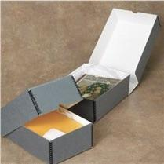
ORGANIZING THE ARCHIVE

BOOK BOXES

The CAWS Archives Committee ought to be responsible for collecting, preserving and cataloging all pertinent analog and digital items. Therefore, the CAWS Archive ought to be organized into the following categories:

A = Audio: C.A. Event Speakers and C.A. Historical Interviews recorded in various file formats, including, cassette and reel-to-reel tape, mp3, wav, etc.

B = Books: Hardcover and Softcover HFC I, II, A Quiet Peace, etc.

C = Ceramics: Coffee mugs, teacups, glassware, plates.

CH = Chips: Plastic, metal and commemorative C.A. tokens, Eternity and Principles chips, etc.

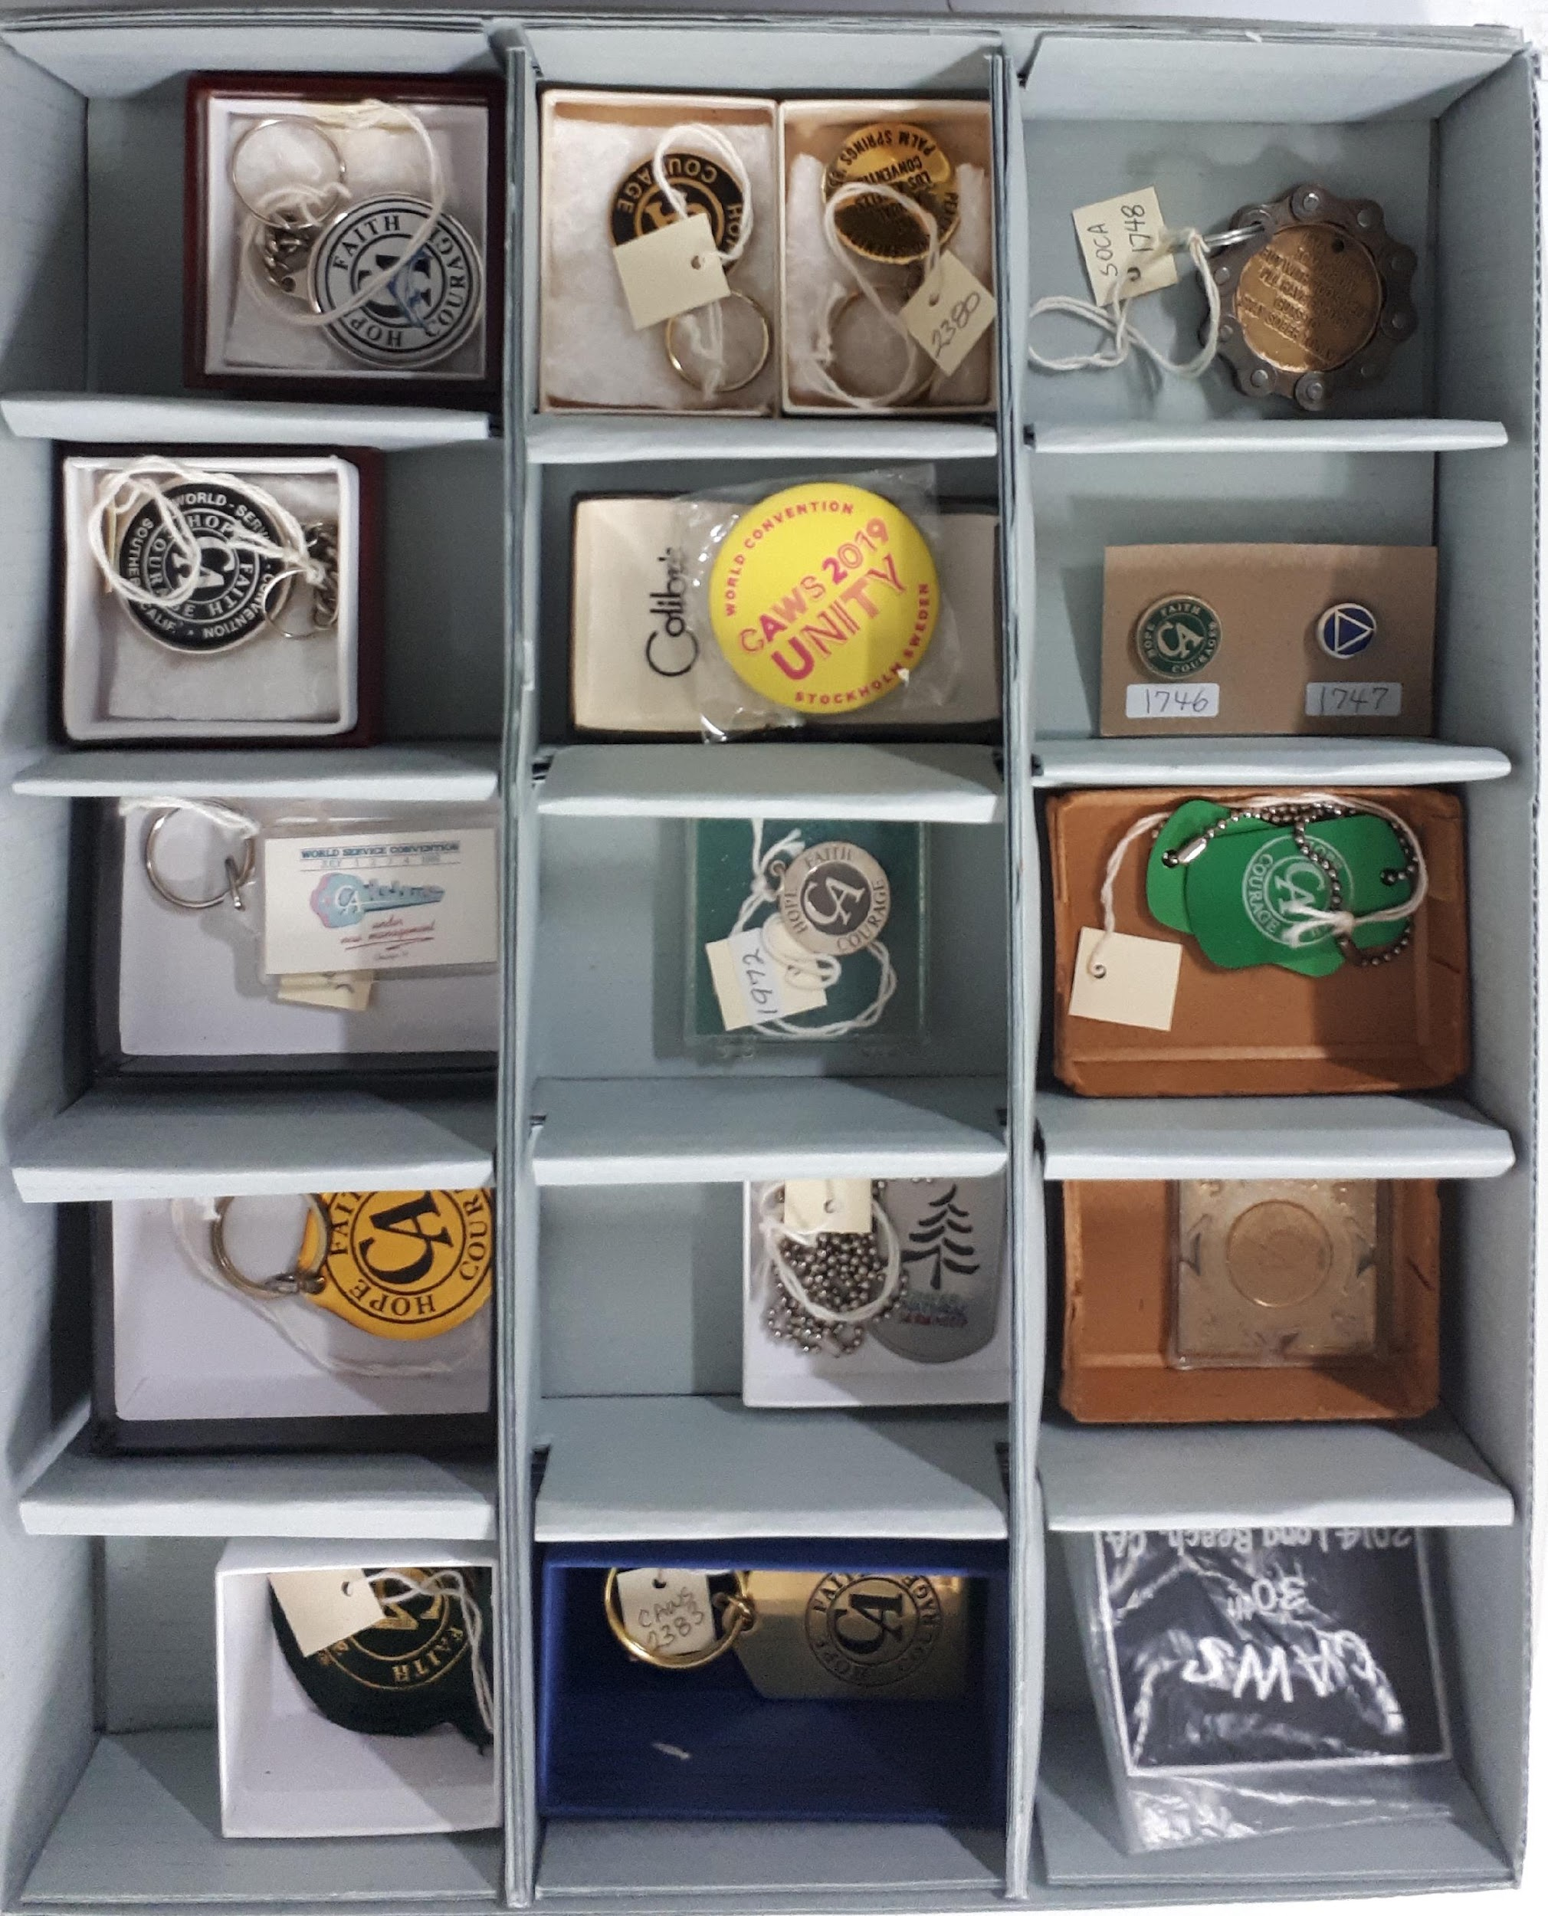
D = Digital: Hardware and software: Hard-drives, CD-ROM, DVD, M-Discs, Thumb-drives, Computer files (i.e. docxs, pdf, jpegs, etc.)

SMALL OBJECTS BOX

LG = Large Format: Banners, Posters, Signage and all other large display items.

M = Miscellaneous: For whatever doesn’t fit into a specific category.

O = Objects: God boxes, umbrellas, mouse pads, artwork, jewelry, vases, artwork, golf balls & tees, key chains, buttons, etc.

P = Pulp: Paper documents such as, fliers, newspaper, C.A. pamphlets, guidelines, magazine articles, tickets, photographs, ought to be digitally scanned (300 dpi or higher for print resolution) (if there is no associated electronic file).

Paper documents ought to be placed in acid-free Mylar sleeves and stored in either binders or acid free boxes.

- Conference, WSOB and WSBT Minutes
- Delegate Mailings
- Convention Programs, Registration Brochures, Event Ephemera
- National Directories, Flyers
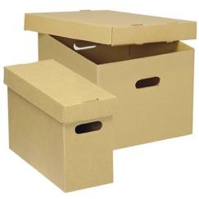
- Legal Documents, incorporation papers, legal suits, etc.

ACID-free document storage boxes

- Financial Records

Mylar sleeves for pulp documents
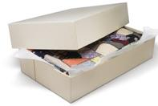

acid-free textile storage box
T = Textiles:

All fabric items - T-shirts, jackets, hoodies, sweatshirts, sweat pants, shorts, boxers, polo, baseball, soccer, et al shirts, ball caps, quilts, cloth banners, bandanas, towels, etc.

Fabrics ought to be stored in linen clothing bags or place in archival fabric storage boxes.

Dangers to all textiles include: light (both artificial and daylight), dirt, dampness, insects, and excessive heat.

CATALOGING THE ARCHIVE

The CAWS Archive catalog provides an inventory of what items are in the collection.

Box Inventory Record - A Simple Inventory Approach (Appendix III & IV)

- Box or Tube Number / Acid Free (YES / NO)
- Box Content List / Description
- Archivist who conducted the inventory
- Date when the Inventory was taken

—————————————————-

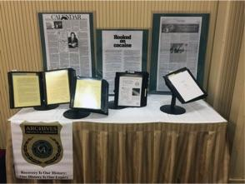
CURATING ARCHIVAL DISPLAYS FOR C.A. EVENTS

Historical Flip Books

The WSC Archive Committee has created a series of historical displays and slide presentations. Historical flip books containing scanned documents, early fliers, newspaper articles, etc. are made available by request.

https://ca.org/service/world-service-conference/archives/archive-request-form/

To download a C.A. historical slide-show, please visit:

https://museum.ca.org/wp-content/uploads/downloads/CAWS-History-Slide-Show.pdf

Every C.A. Object Has A Story:

Created in March of 2018 – The “C.A. Virtual Museum” promotes the value of a Cocaine Anonymous archives and highlights interesting C.A. objects from around the world and their representative C.A. Areas. The C.A. Virtual Museum allows C.A. members to have greater access to their collective history. Please Visit the C.A. Virtual Museum https://museum.ca.org

—————————————————-
CREATING A DIGITAL REPOSITORY
DIGITAL (Electronic File )Archive Practices
The advantage of a C.A. Digital Archive is that it takes up little physical space and can be backed up to multiple redundant storage media i.e. M-disc, thumb-drives, external hard-drives, and server-side cloud accounts. For example, the CAWS digital archive (as of Sept. 22, 2021) has 18,266 files and takes 107.4 GB of disk space. Therefore, it is important to organize your digital archive so that files can be easily and readily obtained when required. The following suggestions are some best practices we use today.
ORGANIZING A DIGITAL REPOSITORY
Folder File structure: Hierarchical file structures can add additional organization to your files. As with file naming, use whatever makes most sense for your data.

• Top Level Folder - CAWS Archives
  - Sub-Folder - CAWS Conference Minutes
    - Sub-Folder - 2019 WS Conference Minutes
      - Document - 2019-08-28 Conference Day 1 Minutes.pdf
  - Sub Folder - WSOB Minutes
    - Sub Folder - 2019 WSOB Minutes
      - Document - 2019-01-16 WSOB Minutes Approved.pdf

Suggested Uniform Naming Conventions
The following uniform naming conventions have been suggested to provide guidance on consistent production of naming files to ensure the ability of fellowship members to retrieve said documents.
Element | Description | Examples
Date | Date associated with the document (generally date of document creation or date of meeting memorialized) | YYYY-MM-DD,  YYYYMMDD
Service Body | Committee, Board, Area/District, etc. associated with document | LCF, CALA, Archives
Title or Project Name | A brief description of what is being documented | Pamphlet X, Conference Call
Type of File | If applicable (to help distinguish agendas and minutes for the same date, for example) | Agenda Minutes, Report, Guidelines
Status | Status of the document (general) | Draft, Final, Approved
Conference Approval Status | More specific status if document is to be presented at Conference | SR13 draft, SR14 draft, WSC approved
Version/Revision | Changes made to the original document are tracked  - Distinct version each time the document is changed  - Who made the change | v3-KS
File Extension | What type of document is being saved | .doc, .docx, .pdf, .wav, .mp3, .png, .tif/.tiff

Uniform Examples:
2020-11-14 SOCA Area Minutes approved.pdf
20201114 LCF Pamphlet X Point 6 draft v3-KS.docx
2005-08 WSC Finance Committee Report.docx (if the day is not given, use only 6 digits)
2021 PI Guidelines WSC approved.docx
Version Control:
- Why changes to a document were made can be explained outside of the title.
- References can also be provided within the document to explain any problems that were fixed, or amplifications introduced, by the changes made.
- It can be easy for files to accidentally be overwritten or deleted when working collaboratively, therefore it is important to remember to save version files for working documents.
Change Control:
- The approval of documents based on their relevancy and suitability before they are issued to relevant parties/committees.
- Reviewing and updating documents when it is required (if it is required). This can also include re-approvals.
- Changes and revisions are documented within the status of each controlled document.
- Having available the most relevant or recent version of the document in question when it is needed for usage by fellowship members.
- Making documents legible and named appropriately for ease of identification.
- Having documents ready for distribution within the fellowship.
- Avoiding unauthorized use of documents which are controlled.

Miscellaneous Notes:
- Placing the date at the beginning of the file name aids in computer sorting of the documents by date
- Ideally descriptions will be short as to not overburden the reader with too much information to sort through to find the necessary file
- If using autosave create a copy with the current date before revising a file
- Best practices for file naming are important to ensure time is not wasted searching for the desired file and that files are not lost without the possibility of retrieval
- File naming conventions when used properly allow for an “audit trail” (a record of changes made to a particular file) so that each file can be traced and retrieved
- Automatically generated file names (such as those from a digital camera for images) ideally will be replaced with a file name that meets the conventions outlined above to ensure retrieval is more seamless
Establishing fellowship-wide standards may not be practical, As such, the naming conventions and related practices set forth above are only suggestions. Committees or other service bodies may choose to implement any or all of them. Before implementation, it is suggested that existing practices be carefully reviewed and that a realistic timeline for implementation of new standards be established. If a service body wishes to retain its own practices, hopefully this document will be of assistance in establishing and maintaining internal uniformity and consistency.

SOME NOTES ON DIGITAL FILES

IMAGE RESOLUTION (72 dpi for web and 300 dpi or higher resolution for print quality)

LOSSLESS (EX. RAW) Preserves or captures all the files’ original data. All photos, art pieces, and text are NOT lost. Lossless files can be compressed and still preserve all the files’ data to its original state.

LOSSY (EX. JPEG) Loses the data and quality of an image file, which is irreversible. The Lossy files will get rid of unnecessary data. Making the file smaller and, in the process, reducing the quality of the image.

RASTER (BITMAP) IMAGE FILES (FINITE)

Raster (or bitmap) images are described by an array or map of bits within a rectangular grid of pixels or dots.

JPEG/JPG

JPEG is a raster format and is the most used online file format because of the flexibility of compression. If you need an image to download quickly, JPEG is a perfect choice. Using the method of lossy compression for photos, email graphics, and large web images. Granted, JPEG file sizes can leave a poor-quality image by an increase or decrease of an image compressed. As a result, JPEG’s are created for posting images online and are not recommended for printing.

Use JPEG when:

- You want to send a quick preview image. JPEGs offer the most flexibility with raster editing and compression, making them ideal for web images.
- Downloading a file quickly.
- Working with online photos.

Avoid using JPEG when:

- Needing transparency. JEPGs don’t have transparency channels and must have a solid colored background. GIF or PNG files are best for transparencies.
- You need a layered, editable image. JPEGs are a flat image format, which means all the edits are saved into one layered image and cannot be undone. Use EPS, AI, or PSD files for multi-layered editable images.
- For sharp edges. JPEGs are raster files that are made up of pixels producing blurred edges.

GIF (Graphics Interchange Format)

GIFs are a series of soundless animated videos or images that loop continuously together and doesn’t require anyone to press play.

For instance, GIF files are a web image format, typically used for animated graphics like ads, emails, and social media memes. They are exported in several customizable settings that reduce file size, colors, and image information.

How do you pronounce gif? The creator of GIF says “JIFF” like peanut butter, while a large part of the world calls it “GIFF” with the “GUH” sound. It’s up to you how you want to pronounce it.

Use GIF when:

- Creating web animation. GIF files can hold all of the individual image frames and timing information in one single file.
- Specifically, for online use only.
- Needing a small video file. GIFs can be compressed down tremendously for very simple icons and web graphics.
- Needing transparency videos. Can also place GIFs on any colored background.

Avoid using GIF when:

- You need a photographic-quality image. GIFs have a limit of 256 colors, while photos typically have thousands of colors. TIFF, PSD or JPG files if you need to print photos.
- Needing a layered, editable image. GIFs are flat image formats that stack images on top of each other. Choose a PSD file for fully editable layered images.
- Wanting a high quality video.

PNG (Portable Network Graphics)

PNGs are best used for online text and graphics with high-quality image sizes. They have a built-in transparency background that allows other images to be seen behind them. Also, allowing a true replication of a RAW image with reduced file size. PNGs are quickly becoming one of the most common image formats used online.

Use PNG when:

- Needing high-quality transparent web graphics. PNG images have a variable “alpha channel” that can have any degree of transparency.
- You have illustrations with limited colors. Though any image will work, PNG files are best with a small color palette, or with greater depths of True Colors, you'll have a more vibrant image than you would with a GIF file.
- Needing a large or small file. PNG files can shrink and grow to incredible sizes—especially for simple colors, shapes, or text. This makes it the ideal image file type for web graphics.

Avoid using PNG when:

- You’re working with photos. Thanks to PNGs’ high color depth, the format can easily handle high resolution photos. However, because it is a lossless web format, file sizes tend to get too large to send to a different platform.
- You’re dealing with a print project. PNG graphics are optimized for the screen and not for print. You can use a PNG for print but it is best to use a JPEG or TIFF file for printing.

TIFF stands for Tagged Image File Format which, are large file formats with extremely high-quality raster images used with professional photography. The files; are also used as a storage container for multiple image files like JPEGs to be edited at a later date.
.
Use TIFF when:

- Needing large high-quality prints. Along with RAW, TIFF files are among the highest quality graphic formats available. If your printing photos—especially at enormous sizes—use this format.
- You are making a high-quality scan (300 dpi or higher for print quality). Using TIFFs to scan your documents, photos and artwork will ensure that you have the best original file to work with.
- For storing high quality images together in one place.

Avoid using TIFF when:

- You’re working with web graphics. TIFF files are optimized for transport only, because, they are a very large file size. JPEG or PNG files are your best bet when it comes to displaying high-quality images online or printing quality images.

PSD = Photoshop Document (works with photos).

PSD is a proprietary layered image format that stands for Photoshop Document. These are original design files created in Photoshop that are fully editable with many layers and image adjustments. PSDs are primarily used to create and edit raster images, making them flexible for many different projects. as a result, PSD files can be exported into any number of image file formats, including all the raster formats listed above.

Use PSD when:

- It’s time to retouch photos. Needing to color correct a photo or remove part of a photo? Photoshop is your tool!
- You need to edit artwork for digital or print. That could be a photo, painting, drawing, or anything else. Photoshop is the right tool to make sure every line, shadow and texture is in place.
- You want digital images for the web like social media images, banner ads, email headers, videos etc. Creating these images in Photoshop will ensure they are the right size and optimized for the web.
- Having to create a website or app mockup. Layers make it easy to move UI elements around.

Avoid using PSD when:

- You need to post a photo online or send a preview to a client. The web is JPEG friendly. Convert PSD files to JPEG or PDF first to make sure your audience can see your image quickly.
- You’re ready to print your photos. Many printers won’t accept the PSD format, so first convert to PDF.

VECTOR FILES (INFINITE):

Vector images are described by lines, shapes, and other graphic image components stored in a format that incorporates geometric formulas for rendering the image elements. A Vector file means they can be enlarged or shrunk down to any size, over and over for whatever project you have, and they will always come out looking great.

A RAW image contains the unprocessed data captured by a digital camera or scanner’s sensor. These files are of the highest quality that you can get in any image format. Typically, images are processed and then converted and compressed into another format (e.g. JPEG or TIFF). Raw images store the unprocessed and processed data in two separate files. So you’re left with the highest quality image possible that you can then edit with either Adobe Lightroom or Adobe Photoshop.

There are dozens and dozens of raw formats, but some of the typical formats are CRW (Canon), NEF (Nikon), and DNG (Adobe).

Use RAW when:

- You are shooting and editing photos. Make sure your camera is set to RAW so you can capture the most versatile image. Then, use a compatible photo-editing application to adjust your image lighting.

Avoid using RAW when:

- You’re working with web graphics. RAW is built for photo editing. When you’re ready to present your photos for the web, convert them to JPEG.
- You’re ready to print your photos. Many printers won’t accept raw formats, so first convert to JPEG or TIFF.

PDF (Portable Document Format) is an image file format used to display documents and graphics. No matter the device, PDF files have a powerful vector graphic foundation. They can display everything from digital graphics to spreadsheets while keeping the quality intact. PDF files are often the standard file format requested by printers to be sent into production. Both Adobe Photoshop and Adobe Illustrator can export straight to PDFs. Great for sharing with clients.
.
Use PDF when:

- You’re ready to print. As we mentioned, many printers prefer PDF as their primary delivery format because it is so universal. Check with your printer providers to see how they’d like you to prepare your file.
- You want to display documents on the web. You wouldn’t use a PDF for a single icon or logo, but it’s great for posters, flyers, magazines and booklets. PDFs will keep your entire design in one package, making it easy to view, download, or print.

Avoid using PDF when:

- You need to edit your design. PDFs are great containers but use other applications for creating content. You can edit raster images with Photoshop and vector graphics with Illustrator. After that, You can combine those into a PDF for easy viewing.

—————————————————-
REMEMBER TO BACK UP THE DIGITAL REPOSITORY
It is suggested that all file backups be migrated to an independent cloud account with at least two (2) trusted servants who have full access (login url, user name, password, security questions, etc.) AND that said files (working and archived) be downloaded to a minimum of two (2) hard-drives or thumb-drives. This should be done on a regular basis depending on how often the files are changing i.e. daily, weekly, monthly? Furthermore, it is suggested that the last (2) previous backups be always on file and accessible.

What’s the difference between backup and archiving.

  - Backup is for recovery from hardware failure or recent data corruption or loss.
  - Archiving is for space management and long term retention.

Document Corruption

File corruption usually occurs in the process of incomplete saving of a document, or incorrect saving. To avoid file corruption, make sure to SAVE OFTEN and to a backup to ensure, if there is a loss due to corruption, the file can be retrieved elsewhere.

Best practices suggest having four (4) redundant systems for backing up the digital files.

  - The computer on which the Archive is saved.
  - The cloud backup in which the Archive information is saved.
  - The external hard drive on which the Archive information is saved.
  - An “M-DISC” similar to a CD that has more storage and will last 1000 years.


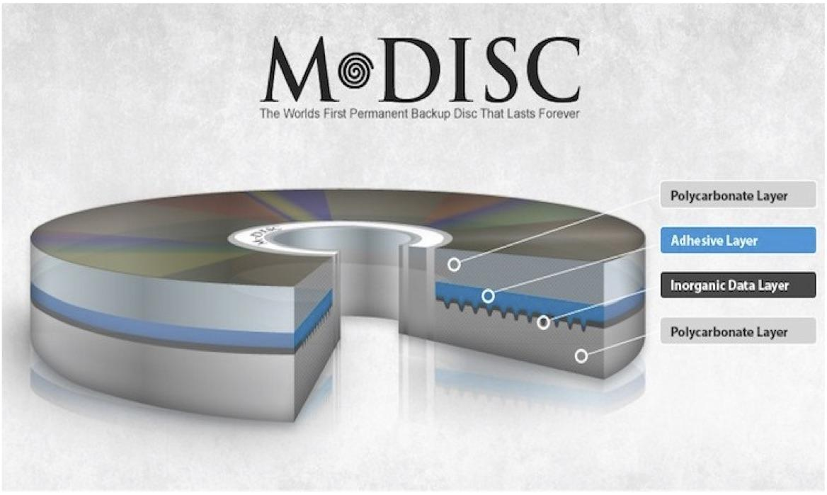
With 4 redundant systems, the chance of losing the majority of the Archive through corruption or total system failure is significantly decreased.

Storage media

long-life archive storage media

—————————————————-

CREATING AN AUDIO ARCHIVE

Of particular interest are the audio histories of our pioneering members. These oral accounts help C.A. to understand its early beginnings with the fellowship and C.A. structure. New C.A. members can learn about where we come from and how we have progressed. There is much wisdom embedded in our collective history.

The information of an audio interview ought to contain historical details of C.A.'s growth. Remember, we are focused on the history of Cocaine Anonymous at the World, Area, District and Group level. These oral history interviews are not about a single individual's personal recovery story, although the interview may touch upon it.

The structure of an audio history ought to record the following:

- Basic Personal Information
- Contributions to C.A. Growth
- Specific Memories
- Involvement with C.A. now
- Closing Comments

Interview questions ought to be administered with consideration of and adherence to the Twelve Traditions of Cocaine Anonymous. The Archive Committee may wish to re-purpose the content of the historical interviews, so a release form from every recorded interviewee prior to the interview will be needed. Obtain a signed audio history release form from every Interviewee recorded for Cocaine Anonymous Area Audio History Archives (See suggested release form - Appendix I).

An audio archives for your C.A. Area ought to include interviews with:

- Area and District Pioneers
- Past C.A. AREA Trusted Servants:
  - Area Chairs
  - Convention Chairs
  - World Service Delegates
  - Service Committee Chairs (Unity, H&I, Special Events)
- Past Regional Trustees

Audio Archiving is another way of preserving our area, district or groups history. At the world level we began the process of conducting oral histories of founding members. The purpose of maintaining and storing an accurate account of earlier membership is so that new members of Cocaine Anonymous can learn about where we come from and how we are progressing and growing. There is much wisdom in our collective "Experience, Strength and Hope."

Conventions, marathons, workshops, and alike are perfect venues to conduct oral histories. The information process should contain historical details of C.A.’s growth. To this end we offer the following suggested topics. Remember we are focused on the History of Cocaine Anonymous and not on a single individual's personal recovery story.

- Basic Personal Information
- Contributions to C.A. Growth
- Specific Memories
- Involvement with C.A. now
- Closing comments.

We have to keep in mind that these interview questions will be administered with consideration of and adherence to the 12 Traditions of Cocaine Anonymous. The Archive Committee may wish to repurpose the content of interviewees into PSAs, pod casts, H&I videos, or use in a traveling archive, and other venues for carrying the message. Please be sure to obtain a release form from every interviewee prior to recording. Please keep in mind some state laws require this permission before making it for public use. It is suggested you also refer to the IT guidelines for information on using these audio archives.

Suggested C.A. Audio Archive Interview Format

The purpose of maintaining and storing an accurate account of earlier membership and how our fellowship developed into what it is now is the goal of the archive committee's historical interview process. Interview questions should always be administered with consideration of and adherence to the 12 Traditions of Cocaine Anonymous.

Introduction: (Hi, Good Morning, etc) this is (first name & initial), from the C.A. World Service Archive Committee. I'm here with (first name & initial) on this (date) and do I have your permission to record this interview for the posterity of Cocaine Anonymous. (Wait for audible response) Thank you.

Closing: I want to thank you for your time today (interviewee's first name). On behalf of the WSC Archive Committee and our worldwide fellowship, thank you for your time and your service.

A. Suggested Topics & Questions for Original and Early Organizers

- When did you come into Cocaine Anonymous?
- How would you describe C.A. in those early days?
  - the name of any particular groups?
  - group size? meeting formats?
  - anything else you remember?
- Did you attend Area or District meetings? If so, what were they like?
  - Did you hold any service positions? If so, which ones?
- Do you remember who your World Delegate/s and Trustees were at that time?
  - What do you remember about them?
- What can you tell me about the history of your District or Area?
  - Inception date? First meeting, early members?
  - Controversies
  - Schisms, splits, new district or Area formations?
- What are some of your most memorable moments in those early days C.A.?
- What were some of the growing pains of C.A. in those days?
  - Can you think of any short-comings of C.A. in those days?
  - In those early days, what do you think C.A. did right?
- Was there any relationship with A.A. in those early days? If so what was that like?
- In those early days, did you attend any C.A. events - local, regional, world? Conventions, Unity Events, etc. If so, what do your remember about them?
- What are your thoughts about how C.A. has developed over the years?
- Do you still attend C.A. meetings?
- Is the C.A. Fellowship different now? How so?
- What would you say to today’s trusted servants?
- How would you like to be remembered in C.A.?
- Is there anything else you’d like to say about C.A.?

B. Suggested Questions for a Standard Audio Archive Interview

These basic questions were created at the 2010 CAWS Conference and approved by the 2011 Conference. They are meant to be an interview framework from which to be drawn.

A. Basic Personal Information

- What name do you go by?
- What is your sobriety date?
- What drugs did you use?
- How were you first introduced to C.A.?
- How did you get to your first C.A. meeting?
- What C.A. meetings did you go to regularly?
- Who took you through the Steps?
- What was your C.A. home group?
- What attracted you or kept you coming back to C.A.

B. Contributions to C.A. Growth

- Do you know who started C.A. in your Area and how?
- What were the meetings like in the beginning?
- Why was it necessary to start C.A. meetings where you lived?
- How did potential members find out about meetings?
- What was the social climate around C.A. meetings at that time?
- How did you attract new members?
- How did C.A. conduct business in the beginning?
- Did you find the World Service Office or did they find you?
- How did meetings change after contact with World Service?
- Do you remember any of the early Delegates from your Area?

C. Specific Memories

- Who else was going to C.A. meetings in those early days?
- What literature was read in early C.A. meetings?
- What was your reaction to hearing “Who’s a Cocaine Addict?” for the first time?
- What’s your favorite C.A. reading?
- Where was the first C.A. Convention you attended?
- Any memorable controversies? Did they help or hinder the growth of C.A.?
- What’s the most fun you ever had in C.A.?
- What is your most memorable moment in early C.A.?
- What growing pains did your Area experience?
- What mistakes were made?
- What do you think you did right?
- What would you do differently?
- Were there any particular difficulties you encountered?

D. Involvement with C.A. Now

- Do you still attend C.A. meetings? If yes, Why? If, no Why not?
- Do you have any C.A. service commitments now?
- What area of service interests you most?
- Is the Fellowship different now? How?

E. Closing comments

- Has the torch been passed?
- How would you like to be remembered in C.A.?
- What C.A. service work gave you the most satisfaction?
- What are you doing to make C.A. be a better Fellowship today?
- What could be done to make C.A. be a better Fellowship?

SOME NOTES ON AUDIO FILES

Uncompressed audio formats encode both sound and silence with the same number of bits per unit of time. Encoding an uncompressed minute of absolute silence produces a file of the same size as encoding an uncompressed minute of music. In a lossless compressed format, however, the music would occupy a smaller file than an uncompressed format and the silence would take up almost no space at all. A compressed audio format stores data in less space without losing any information. The original, uncompressed data can be recreated from the compressed version.

LOSSLESS (RAW) Preserves or captures all the files’ original data. All photos, art pieces, and text are NOT lost. Lossless files can be compressed and still preserve all the files’ data to its original state. Uncompressed audio formats, such as WAV, AIFF, AU or raw header-less PCM. (large files) great for preserving high definition audio recordings. Formats with lossless compression, such as FLAC, Monkey's Audio (filename extension .ape), WavPack (filename extension .wv), TTA, ATRAC Advanced Lossless, ALAC (filename extension .m4a), MPEG-4 SLS, MPEG-4 ALS, MPEG-4 DST, Windows Media Audio Lossless (WMA Lossless), and Shorten (SHN).

LOSSY (MP3) Loses the data and quality of an image file, which is irreversible. The Lossy files will get rid of unnecessary data. Making the file smaller and, in the process, reducing the quality of the image. Formats with lossy compression, common examples include:s MP3, AAC, ATRAC and Windows Media Audio Lossy (WMA lossy). Great for audio voice interviews, speaker shares, etc. *NOTE: For audio interviews or speaker/share recordings, lossy (mp3 or an equivalent is fine for our purposes.
Appendix I: Sample Audio History Release Form

Audio History Release Form for: (Your Area or District) COCAINE ANONYMOUS ARCHIVES

I ____________________________________________________________________________,

hereby give this interview or keynote talk recorded on this day __________________________ to the (Your Area or District) Archives as a donation. With this gift, I transfer to the (Your Area or District) COCAINE ANONYMOUS ARCHIVES legal title and all literary recorded on rights, including copyright.

I understand the recorded interview or keynote talk may be made available for research and Archives may determine. This includes right and license to reproduce, copy, modify, display, distribute, perform, broadcast, transmit, and create derivatives from the recording. This may include use of the interview or keynote talk material in print and in live or recorded programs for radio, television, or any electronic publishing medium.

I transfer all of the above rights without limitation, to support the mission of C.A. and to disseminate information about C.A., upon the condition that I, and any other C.A. member I identify, remain anonymous at the level of the public media, (including, but not limited to, any newspapers, internet, radio, television, press, or other existing or future form of communication which would be available to the general public, rather than just to members of C.A.)

This gift does not preclude any use that I may wish to make of the information in the recordings.

____________________________________________________________________________
Signature of Interviewee or Speaker

____________________________________________________________________________
Name (printed)

____________________________________________________________________________
City State/Province Date Signed

____________________________________________________________________________
Signature of Interviewer (if applicable)

____________________________________________________________________________
Name (printed)

____________________________________________________________________________
City State/Province Date Signed

Additional Comments:

Appendix II: Sample Deed of C.A. Gift Form

Deed of Gift to Cocaine Anonymous World Services.

Thank you for your generous contribution to the Archives of Cocaine Anonymous. Contributions such as yours have made it possible for us to continue building a comprehensive history of our Fellowship. Please know that we are most grateful for your contribution and we will handle it with loving and professional care. We are sure you understand that this is a permanent contribution and we hope you are confident that we will make the best possible use of it.
We think you will feel, as our thousands of other C.A. Members have, that our history is alive and strengthening the Fellowship. Thank you for your loving generosity.

Please fill out and sign the attached form and email it to: (your C.A. Area Archives email address.

C.A. Deed of Gift

I, __________________________________________________________________, residing at __________________________________________________________________________________, hereby gift, transfer, convey and assign to the Cocaine Anonymous Area Archives of ____________________________________ all of my right, title and interest in and to the following property, of which I am the sole owner and which property is free of any liens, claims or encumbrances. This gift is made free of any terms and conditions except: ______________________________________________________________________________
______________________________________________________________________________
______________________________________________________________________________

Signed:_______________________________________________________________________

Dated:________________________________________________________________________

COUNTRY | STATE/PROVINCE | CITY ______________________________________________________________________________

Appendix III: Example of a Box Inventory Record
Recommend one printed copy for the catalog and a duplicate printed copy that goes into the box.

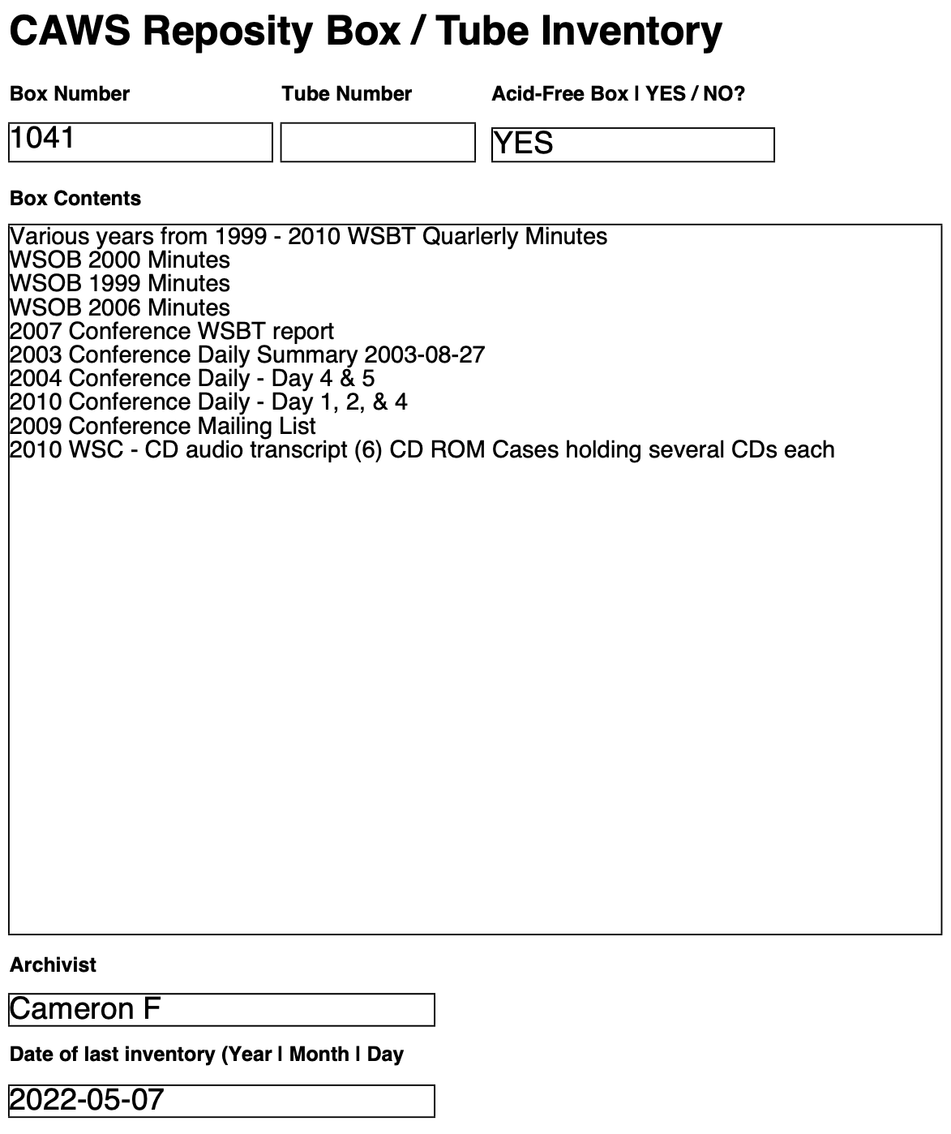
CAWS Repository Box / Tube Inventory
Appendix IV: Example of a Blank Box Inventory Record

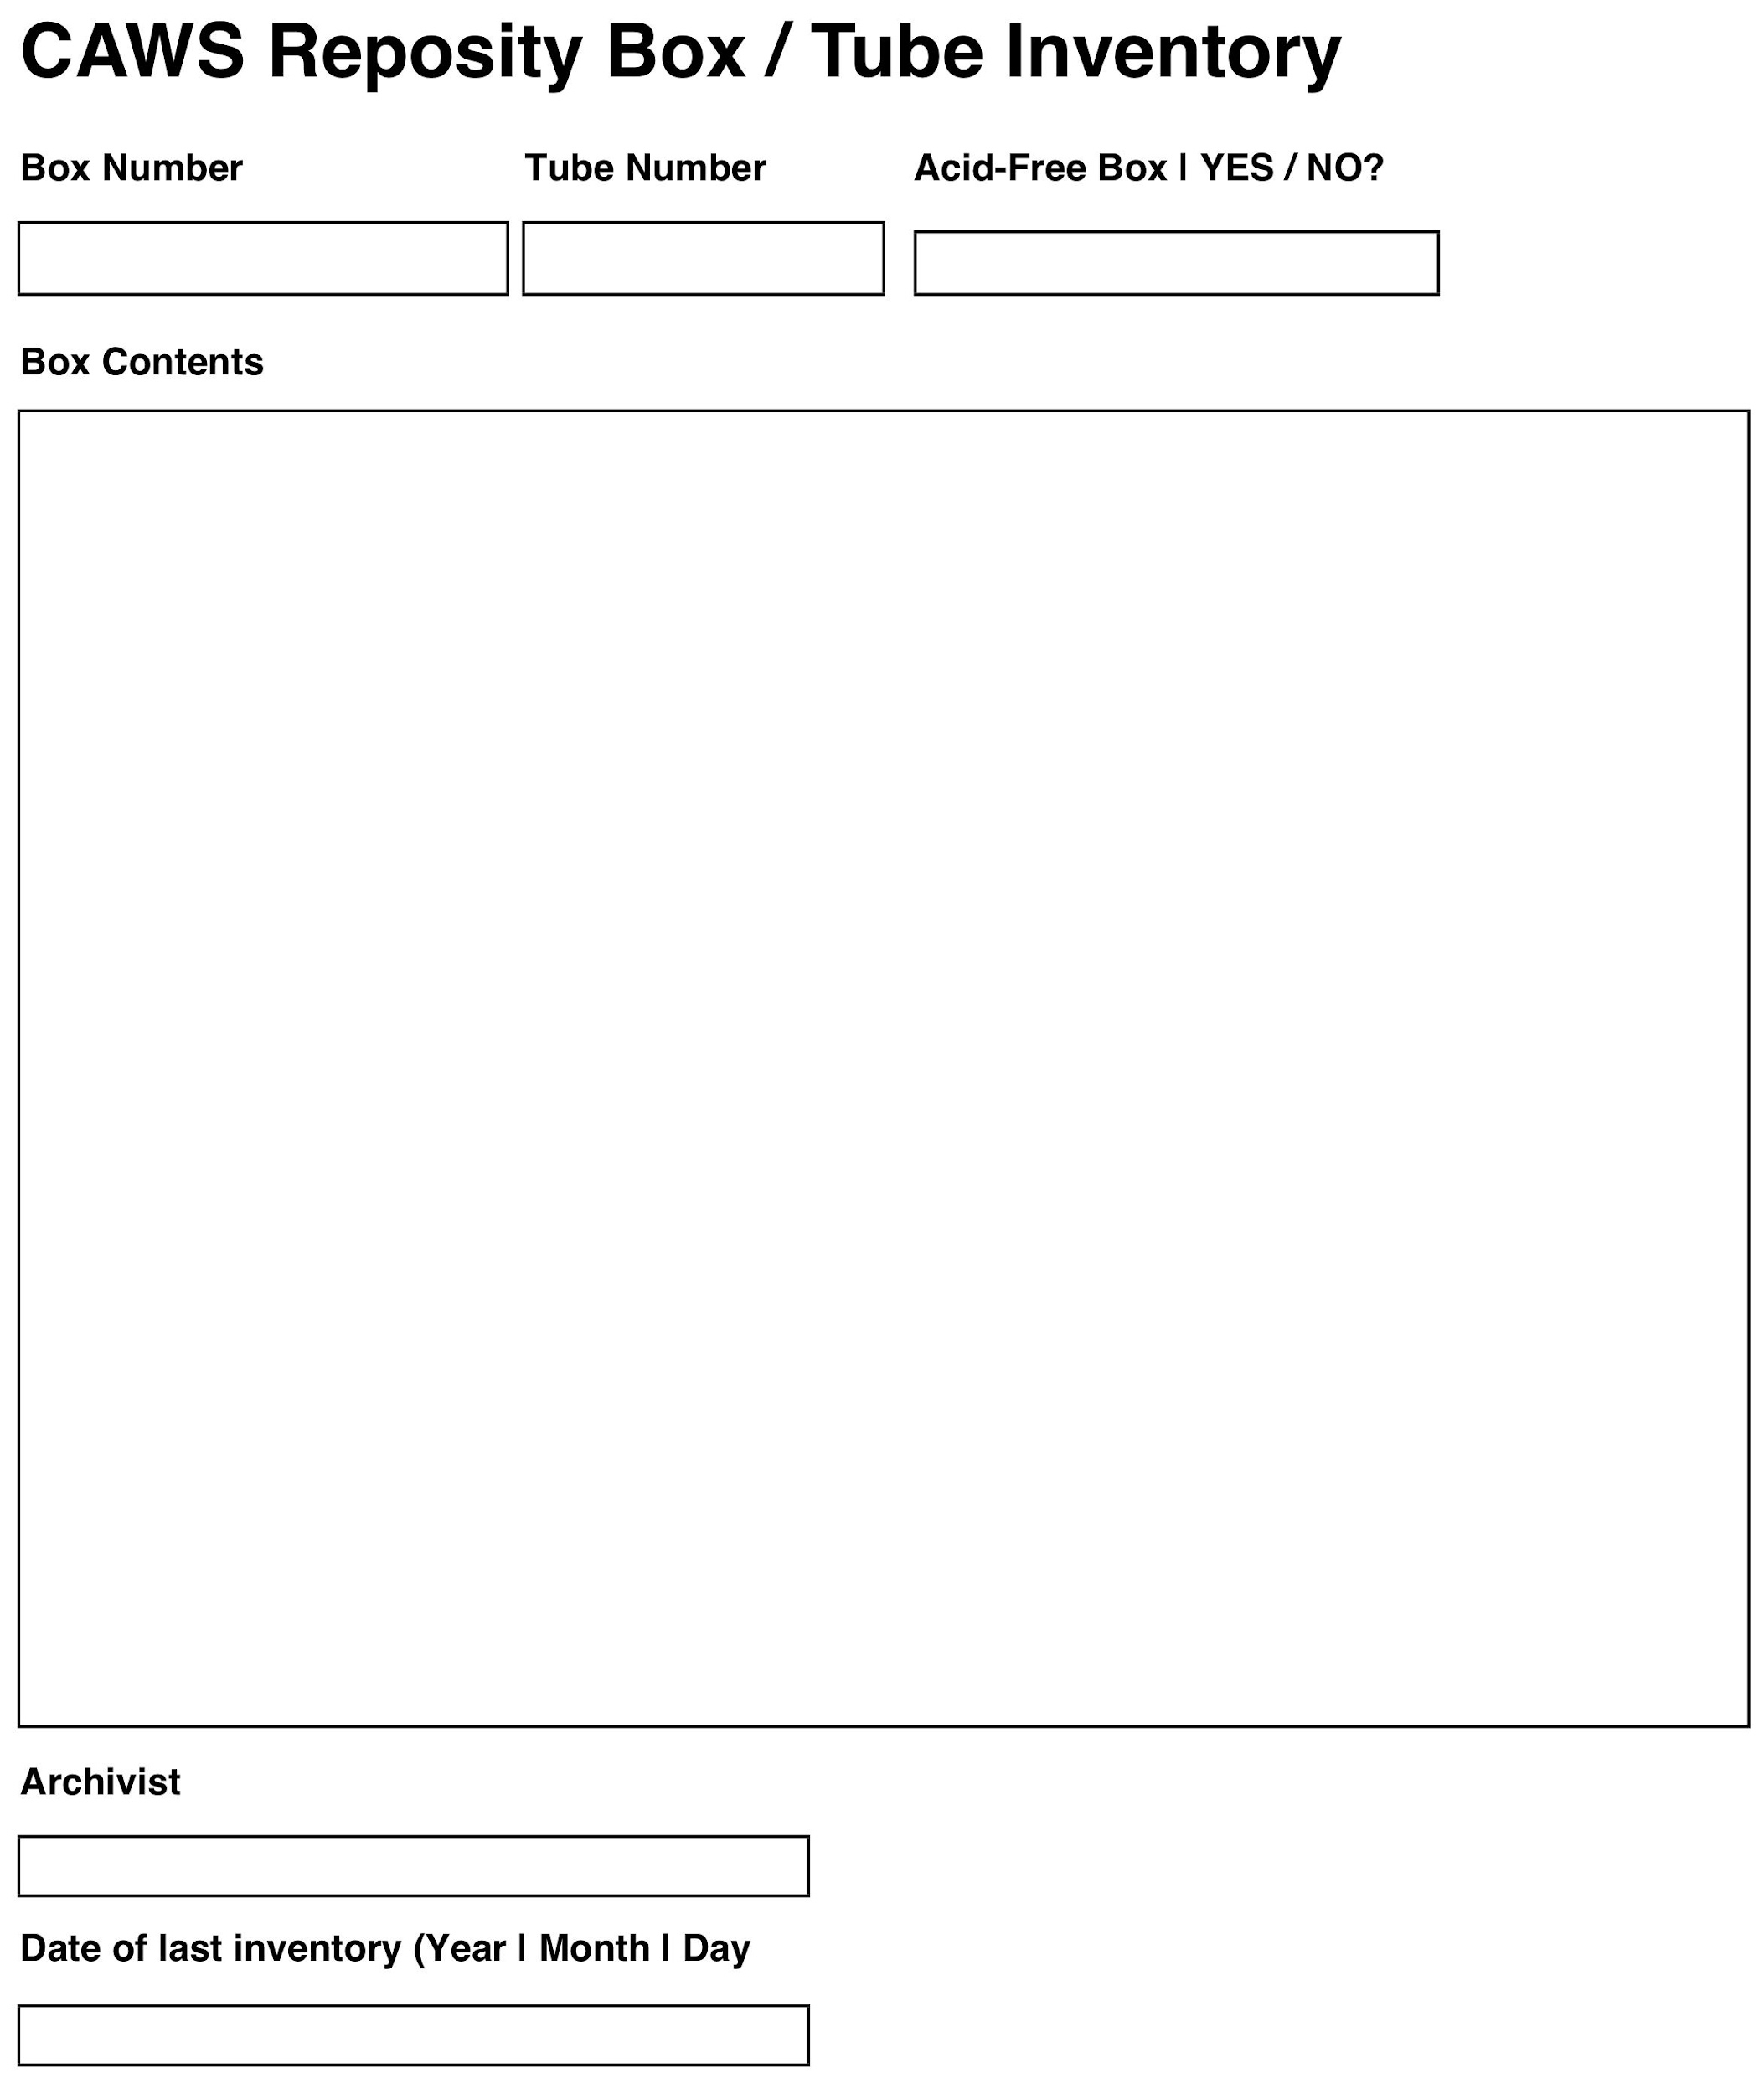
CAWS Repository Box / Tube Inventory

